

**<<Project name>>**

**Software Requirement Specification**

– Hanoi, August 2019 –

**Table of Contents**

1 Overall Description 3

1.1 Introduction 3

1.2 Feature Descriptions 4

1.2.1 Screen Functions 4

1.2.2 Non-Screen Functions 4

1.2.3 Common Requirements 4

1.3 Screen Description 4

1.3.1 Screen Flow 4

1.3.2 Screen Details 4

1.3.3 User Authorization 5

2 System Features 6

2.1 <<Feature Name 1>> 6

1.1 Login 6

1.2 <Use case ID> - <Use case name> 8

1.3 <Name of Function Group> 8

# 1 Overall Description

## 1.1 Introduction

*[Content part 1: presents a high-level overview of the product and the environment in which it will be used, the users, and known constraints, assumptions, and dependencies]*

*[Content part 2: describes the product's context in the form of a context diagram in which you present the boundary and connections between the system you’re developing and everything else in the universe. This identifies external entities (or terminators – software, hardware, human components, and other systems) outside the system that interface to it in some way, as well as data, control, and material flows between the terminators and the system]*

<<Sample: The Cafeteria Ordering System is a new software system that replaces the current manual and telephone processes for ordering and picking up meals in the Process Impact cafeteria. The system is expected to evolve over several releases, ultimately connecting to the Internet ordering services for several local restaurants and to credit and debit card authorization services.

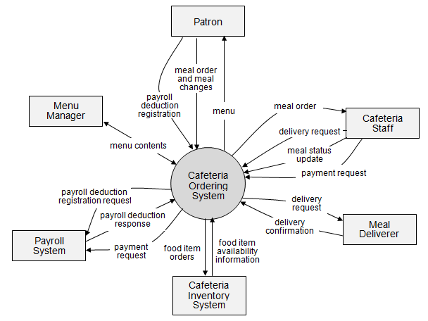

Figure 1-1: Cafeteria System overview

As described in Figure 1-1, the system will have the following component:

……

>>

## 1.2 Feature Descriptions

### 1.2.1 Screen Functions

*[Provide the descriptions for the screen system functions.]*

|  |  |  |  |
| --- | --- | --- | --- |
| **#** | **Feature** | **System Function** | **Description** |
| 1 | <<Feature Name>> | <<Function Name1>> | <<Function Name1 Description>> |
| 2 | … |  |  |

### 1.2.2 Non-Screen Functions

*[Provide the descriptions for the non-screen system functions, i.e batch/cron job, service, API, etc.]*

|  |  |  |  |
| --- | --- | --- | --- |
| **#** | **Feature** | **System Function** | **Description** |
| 1 | <<Feature Name>> | <<Function Name1>> | <<Function Name1 Description>> |
| 2 | … |  |  |

### 1.2.3 Common Requirements

*<<fill here with all the common requirements...>>*

## 1.3 Screen Description

### 1.3.1 Screen Flow

*[This part shows the system screens and the relationship among screens. You can draw the Screens Flow for the system in the form of diagram as below]*

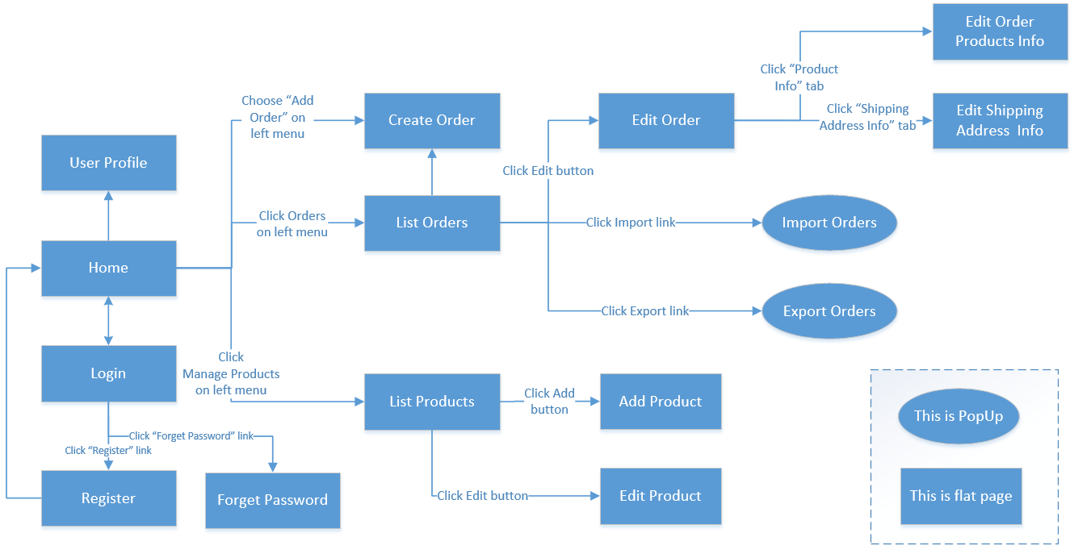

### 1.3.2 Screen Details

*[Provide the descriptions for the screens in the Screens Flow above]*

|  |  |  |  |
| --- | --- | --- | --- |
| **#** | **Feature** | **Screen** | **Description** |
| 1 | Order Meals | Create Order | <<Screen Brief description>> |
| 2 | Order Meals | Change Order |  |
| 3 | .. |  |  |

### 1.3.3 User Authorization

*[Provide the system roles authorization to the system features (down to screens, and event to the screen activities if applicable) in the table form as below – replace Role1, Role2,… with the specific system user role names]*

|  |  |  |  |  |  |
| --- | --- | --- | --- | --- | --- |
| **Screen** | **Role1** | **Role2** | **Role3** | **Role4** | **RoleX** |
| <<Screen Name1>> | X |  |  | X | X |
| <<Screen Activity>> |  |  |  | X | X |
| <<Screen Name2>> | X |  |  | X |  |
| Query All Data | X |  |  |  |  |
| Query Own Data |  |  |  | X |  |
| Query Managed Data |  |  |  | X |  |
| Add New Data |  |  |  | X | X |
| Update All Data |  |  |  |  | X |
| Update Own Data |  |  |  |  | X |
| Update Managed Data |  |  |  |  | X |
| Delete Data |  |  |  |  |  |
| … |  |  |  |  |  |

In which:

* Role1: <<role1 description>>
* Role2: <<role2 description>>
* …

# 2 System Features

## 2.1 <<Feature Name 1>>

### 1.1 Login

#### 1.1.1 Screen Design

|  |  |  |  |  |  |  |  |
| --- | --- | --- | --- | --- | --- | --- | --- |
| **Login** |  |  |  |  |  |  |  |
|  |  |  |  |  |  |  |  |
|  |  | User name |  |  |  |  |  |
|  |  |  |  |  |  |  |  |
|  |  | Password |  |  |  |  |  |
|  |  | Login | | |  |  |  |
|  |  |  |  |  |
|  |  |  |  |  |
|  |  |  |  |  |  |  |  |
|  |  |  |  |  |  |  |  |

**Figure 3-1**: Screen Design of Login

**Table 1-1: Screen Definition**

|  |  |  |  |  |  |
| --- | --- | --- | --- | --- | --- |
| # | Field Name | Type | Mandatory | Max Length | Description |
| 1 | User Name | Text | Yes | 20 |  |
| 2 | Password | Text | Yes | 20 | Display "*" instead of clear character |
| 3 | Login | Button |  |  | Go to home page |
| 4 | Close | Button |  |  |  |
|  |  |  |  |  |  |
|  |  |  |  |  |  |

#### 1.1.2 Use case Specification

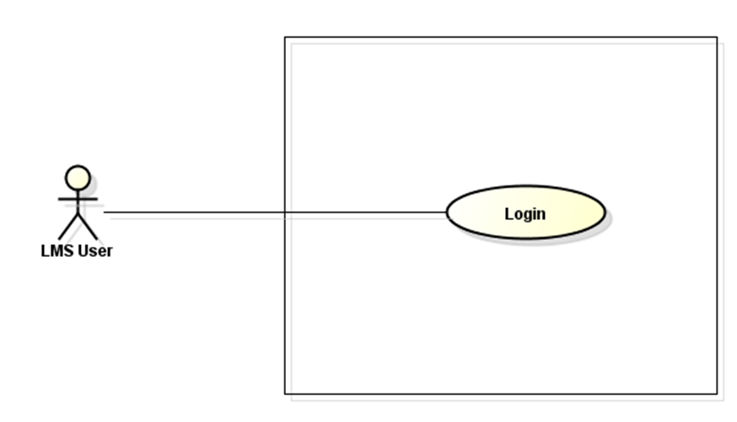

LMS

**Figure 3-2:** Login Use-Case Diagram

|  |  |  |  |  |  |  |
| --- | --- | --- | --- | --- | --- | --- |
| **Use Case ID** | | **UC01** | **Use Case Name** | | **Login** | |
| **Author** | | **HungNV** | **Version** | **1.0** | **Date** | **11/05/2013** |
| **Actor** | | LMS User | | | | |
| **Description** | | The function allows a user to be able to login in the software when he/she have registered an account and his/her account is still active. | | | | |
| **Precondition** | | PRE-01:  PRE-02: | | | | |
| **Trigger** | | TRG-01: | | | | |
| **Post-Condition** | | POS-01: | | | | |
| **Main flows** | | | | | | |
| ***Step*** | ***Actor*** | ***Action*** | | | | |
| *1* | User | Type URL into location field of internet browser and then press enter | | | | |
| *2* | LMS | Display Login screen with the following fields:  - User Name  - Password  - Login and Close button | | | | |
| *3* | User | Enter user name & password into User Name & Password fields on the Login screen, then click on Login button. | | | | |
| *4* | LMS | Validate the entered user name & password and then display Home screen | | | | |
|  |  |  | | | | |

**Alternative flows**

|  |  |  |
| --- | --- | --- |
| **AT1** | At step 2 in the main flows**,** if there is an internal error in the system, | |
| **Sub step** | **Actor** | **Action** |
| 2.1 | LMS | Display "Error" page with message "Internal System Error, please contact with administrator" |
|  |  |  |
|  |  |  |

|  |  |  |
| --- | --- | --- |
| **AT2** | At step 4 in the main flows**,** if LMS failed to validate user name & password | |
| **Sub step** | **Actor** | **Action** |
| 4.1 | LMS | Display "Login" page with message "Your user name or password is not correct." |
|  |  |  |

***Business Rules***

|  |  |
| --- | --- |
| ***#*** | ***Rule Description*** |
| *BR01* |  |
| *BR02* |  |

### 1.2 <Use case ID> - <Use case name>

#### 1.2.1 Screen Design

*[Mock-up and screen description which should include field name, type, field length…*

*Mock-up và mô tả mock-up]*

#### 1.2.2 Use case Specification

*[Specify use case diagram, use case specification details, business rules...]*

### 1.3 <Name of Function Group>

#### 1.3.1 Use Case diagram

*[Include use case diagram and use case description]*

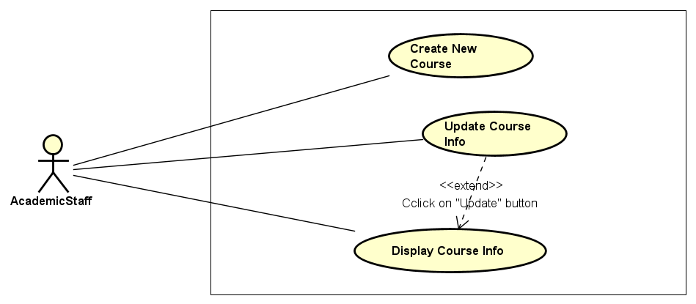

|  |  |  |
| --- | --- | --- |
| Use Case ID | User case Name | Description |
| UC-0201 | Create New Course | Allow an authorized user to create a new course in the system |
| UC-0202 | Update Course Info | Allow the user to update the course information |
|  |  |  |

#### 1.3.2 <Use case ID> - <Use case name>

##### 1.3.2.1 Screen Design

*[Mock-up and screen description which should include field name, type, field length…*

*Mock-up và mô tả mock-up]*

##### 1.3.2.2 Use case Specification

*[Specify use case specification details, business rules... – No use case diagram]*

#### 1.3.3 <Use case ID> - <Use case name>

##### 1.3.3.1 Screen Design

*[Mock-up and screen description which should include field name, type, field length…*

*Mock-up và mô tả mock-up]*

##### 1.3.3.2 Use case Specification

*[Specify use case specification details, business rules... – No use case diagram]*